**........................................**

**Challenge 4**

**........................................**

**Challenge Link** --> "<http://www.pythonchallenge.com/pc/def/linkedlist.php> "

An image is displayed:

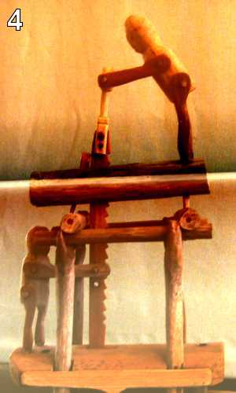

This time there is no hint given. So as in previous challenge we go through the source code of the page. I go the source code and found a hint, commented in the source code i.e " ***urllib may help. DON'T TRY ALL NOTHINGS, since it will never end. 400 times is more than enough.*** "

In the source code we are provided with this href="linkedlist.php?nothing=12345"

As you will open this link, it will show "and the next nothing is 44827" and so on by changing nothing value.

So, we have to make a program to make it run till some text come to make challenge complete or provide with some hint to complete this challenge.

I made a python program (challeneg_4.py) which will execute till next hint is given. The last nothing value came after running the program is "16044". When we open the link with 16044 value of nothing, the message comes as "Yes. Divide by two and keep going."

So now we have to divide "16044" with 2 and continue the same code again till the next text message else then value of nothing.

After running, I got the last value of nothing i.e "66831".

Then opening the link with nothing value = 66831.

I got the link for next challenge.